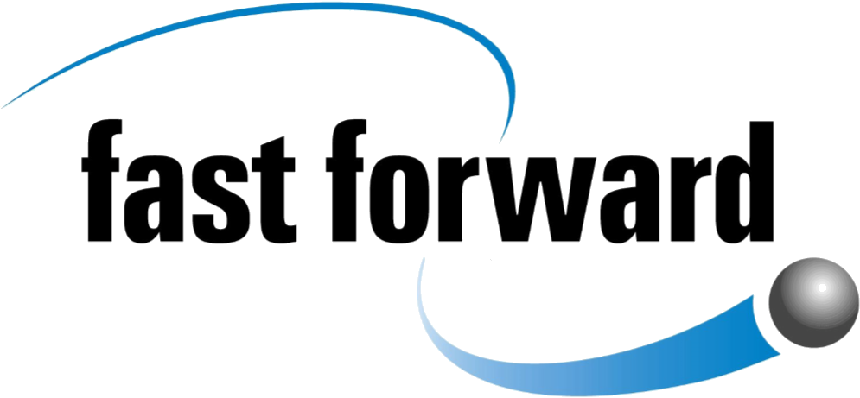

Project Officer (Scottish Gambling Education Hub)

Region: Ayrshire and South Scotland

Organisation: Fast Forward (Positive Lifestyles) Limited
Salary: £27,516 (35 hours)
Status: Full time post, fixed-term contract until March 2029 (6 month probation period)
Closing date: Monday 27th July 2026
Location: Hybrid working; 3 days home based, 2 days locality co- working space.
You will be required to work at the Fast Forward office (4 Bernard St, Edinburgh, EH6 6PP) 1 day per month.
Website: http://www.fastforward.org.uk
___________________________________________________________________
Do you enjoy working with people?
Do you have excellent communication and presentation skills, and experience working with young people?
We are looking for an enthusiastic Project Officer to join Fasy Forward’s existing Scottish Gambling Education Hub. This role will have a focus on working in the community with young people, practitioners and families living and working in and around Ayrshire and South Scotland.
We are looking for an enthusiastic practitioner with excellent communication skills and robust track record of working in the community with young people, practitioners and families.
The Hub was Scotland’s first gambling education and prevention programme focusing on protecting young people from gambling harms. Its work includes delivering training to practitioners, staff, schools and youth groups, developing resources, as well as partnership building with national organisations.

Organisation profile
Fast Forward is Scotland’s national youth work agency, it is a force for change supporting children and young people to make informed decisions about risk taking behaviours. We take a harm reduction approach to reduce the negative impacts of these behaviours on their lives and those of their families and wider community.
The team’s work is dynamic, challenging and rewarding in developing innovative programmes to address risk-taking behaviours that often goes unrecognised. You will find creative ways to engage with partners, adapting and creating resources to enable them to better deliver meaningful harm reduction and prevention education around harmful gambling and gambling harm.
Our work is underpinned by the following values:
Integrity - Our work is dynamic and informed by expertise, lived experience and relevant research
Forward Thinking - We are brave and bold. We are creative in our approach to identifying and responding to risk taking behaviour.
Inclusive - We take a person-centred approach. We are non-judgemental and respectful.
Collaborative - We coproduce, partner and learn with young people and experts from across the field.

Application notes
An application pack is available for download below.
If you would like to discuss this vacancy, contact Dina Subasciaki, Project Manager, dina@fastforward.org.uk
Please complete all sections of the application form and other documents and return to dina@fastforward.org.uk by noon on Monday 27th July 2026.
Candidates will be invited to meet members of the Fast Forward staff team digitally on Friday 31st July 2026.
Interviews will be held in person on Monday 3rd August at Ayr Town Hall, 21 New Bridge Street, Ayr, KA7 1JX.

