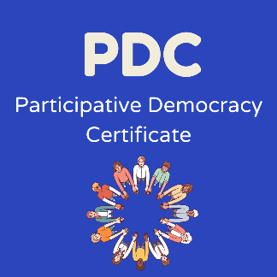
Lead Youth Worker’s Observation Report

Name of participant:
Group:
Name of Lead Youth Worker:

Number of meetings attended
Dates of meetings attended

The Young Person will be able to work in a group by:
- Actively participating in a group discussion.
- Understanding the needs of other young people.
- Making decisions and recommendations.
- Listening, negotiating, participating and involving others

Learning Outcomes Achieved

1.2 Demonstrate an ability to communicate effectively with  their peers.  . | ☐
2.3 Demonstrate communication skills through group and  paired activities. | ☐
2.4 Identify and articulate communication skills. | ☐
2.5 Support and promote communication by peers. | ☐
3.1 Work within a team. | ☐
3.4 Recognise and demonstrate practice of group work process. | ☐
3.10 Actively participate in a group discussion. | ☐
3.13 Make joint decisions | ☐
Please comment on any specific role or responsibility undertaken by the participant within the group and use the points given above to reflect on their learning and development of working in a group. Please also comment on the skill development of the participant throughout the programme in the 4 key skills areas identified in their skills questionnaire: confidence, communication, teamwork and communication.

Lead Youth Worker: Date:

