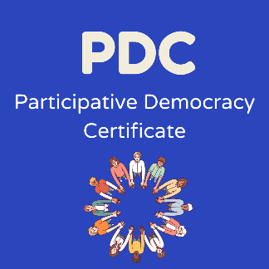
Lead Youth Worker’s Observation Report

Name of participant:
Group:
Name of Lead Youth Worker:

Number of meetings attended
Dates of meetings attended

The Young Person will be able to work in a group by:
- Actively participating in a group discussion.
- Understanding the needs of other young people.
- Making decisions and recommendations.
(Skills of working in a group are: Listening, Negotiating, Participation, Involving Others)

Learning Outcomes Achieved

1.2 Demonstrate an ability to communicate effectively with  their peers.  . | ☐
2.3 Demonstrate communication skills through group and  paired activities. | ☐
2.4 Identify and articulate communication skills. | ☐
2.5 Support and promote communication by peers. | ☐
3.1 Work within a team. | ☐
3.4 Recognise and demonstrate practice of group work process. | ☐
3.10 Actively participate in a group discussion. | ☐
3.13 Make joint decisions | ☐
Please comment on any specific role or responsibility undertaken by the participant within the group and use the points given above to reflect on their learning and development.

Lead Youth Worker: Date:

