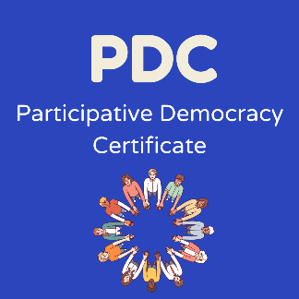
Personal Reflection:

PDC Skills questionnaire

Name:

The PDC embeds the National Youth Work Outcomes & Skills Framework into its programme, supporting you to recognise and articulate your development around 4 key skills:
- Confidence
- Teamwork
- Decision Making
- Communication

Baseline Questionnaire
Please grade your skills competency for the 4 skills listed below at the start of the PDC project
Skill | Very Low | Low | Average | Good | Very Good
Confidence | ☐ | ☐ | ☐ | ☐ | ☐
Communication | ☐ | ☐ | ☐ | ☐ | ☐
Decision Making | ☐ | ☐ | ☐ | ☐ | ☐
Team Work | ☐ | ☐ | ☐ | ☐ | ☐

End Questionnaire
Please grade your skills competency for the 4 skills listed below at the end of the PDC project and give examples of how you developed these skills through working on your PDC project. Please also gather peer feedback with examples of how you developed each of these skills. Performance indicators have been listed to help prompt these examples of skills development if needed
Skill | Very Low | Low | Average | Good | Very Good
Confidence | ☐ | ☐ | ☐ | ☐ | ☐
Examples?

- I can participate in new opportunities and experiences
- I can identify the new skills and knowledge I’ve developed
- I can use my learning and skills in different settings
- I can learn from my mistakes

Skill | Very Low | Low | Average | Good | Very Good
Communication | ☐ | ☐ | ☐ | ☐ | ☐
Examples?

- I can express my thoughts and feelings to appropriate adults
- I can speak in a group and share my opinions
- I can listen to other people’s opinions
- I can construct and defend an argument
- I can communicate effectively using a range of methods

Skill | Very Low | Low | Average | Good | Very Good
Decision Making | ☐ | ☐ | ☐ | ☐ | ☐
Examples?

- I can think critically about information
- I can explain why I made a choice
- I can participate in decision making processes

Skill | Very Low | Low | Average | Good | Very Good
Team Work | ☐ | ☐ | ☐ | ☐ | ☐
Examples?

- I can work with others on group tasks
- I can support other young people in a group
- I can understand the role of power within groups
- I can give and receive feedback
- I can be reliable

