Reflections of Covid and mental health
By St Mungo’s Young People
WEBSITE DESIGN
Playlist
Audio 1 – Who we are?
Audio 2 – Our theme of loss and bereavement
Audio 3 – Story of how Covid changed everything?
Audio 4 – Story of Isolation
Audio 5 - Story of Bereavement and Family Relationships
Audio 6 - Story of Emotional Eating
Audio 7 - Story of Stained Family Relationships
Audio 8 - Story of loss of Friendship
Audio 9 - Story of Social Media
Audio 10 – Podcast Emily Gillies
Audio 11 – Podcast Graham Russell
Audio 12 – Podcast Ciara Ferla
Audio 13 – Podcast Eilidh McFadden
Audio 14 – Podcast Joseph O’Connor
Audio 15 – Podcast Janet Cardle
Audio 16 – Podcast Leanne Peebles
Audio 17 – Podcast John McNee
Audio 18 – Podcast Megan Craig
Audio 19 – Podcast Mhairi Sneddon
Audio 20 – Podcast Safia Ali
Audio 21 – Podcast Sara McCallum
Audio 22 – Podcast Tom Kearns

Audio 1 – Who we are
We are a group of young people from St Mungo’s Academy in Glasgow. Our school’s motto is ‘Bringing out the best’ for all our pupils, and mental health is an essential part of this vision. One of the school’s aims is to promote pupil participation and empowerment. Numerous groups of young people have been passionate over the past 2 years to raise awareness of mental wellbeing and to support pupils to understand and manage their mental health. Over the past year, we have started to take new approach to promoting mental wellbeing through music, signposting and the production of pupil-friendly information; but this is not enough. The reach is not enough, and we wanted to do more.
As part of our school’s work in supporting our pupils, especially with in promoting youth participation and empowerment, the school has been working with FARE Scotland. FARE is a voluntary organisation that strives to raise people's aspirations, encourage them to become more involved in their communities, create opportunities for personal development, and equip them with the skills required to deal with the demands of 21st century life. This partnership has included the development of our school’s youthwork approach which has been led by our Youthwork Co-ordinator to support a group of us to take our mental health work to the next level over the summer holidays.
As a group we have been working on different resources and activities looking at mental health. Before the Pandemic we were looking at loss and bereavement and different ways we could deal with this. During Covid-19, this seems to be so much more prevalent with loss being a feeling experienced by most, whether that be loss of routine, friendships or even a bereavement. To support young people with this topic, we have created this podcast to start conversations about loss and how we deal with this during this difficult time.
We do hope that these conversations allow you to come up with new ideas to keep your mental health positive.
Please note these conversations may trigger you, please see helpline information if you need to talk to someone.
Creators of course – Our best coping strategy
- John McNee - Walking
- Julia Serdycka – Exercise
- Ciara Ferla – Fiction
- Rebecca Greenhow – Fiction
- Muhammed Saad Khan – Spend time with family
- Aakansha Singh – Reading books
- Liliana Piotrowska – Writing songs
- Hazel Hepburn -
- Joseph O’Connor – Writing stories
- Pamela Graham – A good sleep
- Keri Hughes – Writing and reading
- Eilidh McFadden – Exercise/Dance
Audio 2 Explain themes
We have chosen the theme of loss and bereavement for these podcasts.
Loss can be a loss of anything such as:
  - Imprisonment
  - Seeking asylum, refuge
  - Loss of a pet
  - Health, illness, disability
  - Death
  - Unemployment
  - Retirement
  - Moving home
  - Divorce
  - Separation/ change in relationship’s

Grief is:
A massive bundle of different emotions and intense feelings. Feeling sad and missing somebody. Love happens and people die in your family. Someone who has lost someone and they can’t get over it. You cry over someone dying. You cry then you stop. Then you cry, then you stop. – taken from Child Bereavement UK.
Whatever you feel is how you feel. You may experience a mixture of feelings all at once. It helps if you can learn to recognise your feelings.

You may feel……
Numbness when you think you should be feeling very upset. Lots of young people have told us they feel numb at first.
Disbelief: You might find it hard to believe this has happened and you may expect them to walk through the door at any time
Confusion about what has happened and the way everything in your life has changed. You may feel you have lots of unanswered questions.
Worry, perhaps about the future, who will look after you, your siblings or your parent? You may feel you have new responsibilities and worry about how to cope with these.
Anger. There is not always an easily understood reason for anger but it is perfectly natural to feel it.
Guilt and Regret. It is very normal to think that you could have done more or that you should have behaved differently. It was not your fault and there is nothing you could have done to prevent the death.
Loneliness: You may have a good group of friends but if none have experienced your situation, then you can feel lonely even when surround by people. Even with your family, if you are all grieving differently, bereaved young people tell us you can feel very alone.
Overwhelmed. You may feel completely overwhelmed by powerful feelings and emotions that you do not understand or expect.
Grief also has physical effects: You could go off your food or even find it becomes tasteless. You may find it hard to sleep, and as a result, become tired and irritable, especially when trying to concentrate at school or work.

No matter how you feel:

Take care of yourself – grief can be physically and emotionally draining. Remember to take care of yourself by eating healthily, doing regular exercise and getting enough sleep. When you feel ready, try to get back into your normal routine. Avoid alcohol and drugs, as they can numb your feelings and make it harder to heal.
Take your time – when you lose someone or something important, it takes time to get back into life. There isn’t a set time limit on grief, so try not to put pressure on yourself or others to “move on” or “get over it”. Avoid making any big decisions until you are able to think more clearly.
Let others help – it can be hard to accept help from family and friends. Sometimes they don’t know how to support you during this difficult time. Explain how you’re feeling and what others can do to help. It may be emotional support or helping with more practical things, like cooking, running errands or looking after children.

Do things you enjoy – it’s important to take “time out” from your grief to enjoy life and have fun. Even when you’re feeling down, try to regularly connect with family and friends and get involved in activities that you enjoy. This will help you to stay healthy and assist in the healing process.

HELPLINE CARD

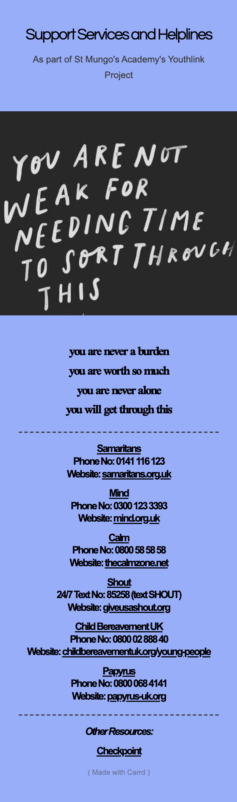

COPING STRATEGY CARDS

List Coping Strategies

Find something you love to do
Write your grief down on paper – journal
Supporting yourself with positivity
Support group
Listen to music
Have a dance a party all by yourself
Find a new hobby
Occupy your time
Find more active things to do
More social interaction
Speak to someone you trust
Look at the positives instead of the negatives
Celebrate the positives/ little things
Online resources
Be mindful of what you are saying
Reminder of people’s boundaries

HAPPY PLAYLIST
- https://www.youtube.com/watch?v=HgzGwKwLmgM&list=PLP05dpNbGUsyWz51i_RNkX65UTZ96PjB4

